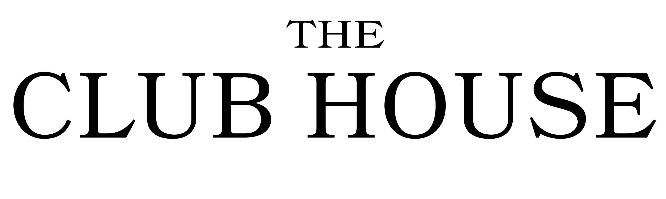

Breakfast Menu

Sample Menu

Club House Breakfast £13
Local smoked back bacon, local pork sausage, free range fried egg, hash brown, thyme tomato and local black pudding

Crab Benedict £14
Handpicked white and brown crab meat on a toasted English muffin with soft poached eggs finished with a hollandaise sauce.

Avocado on toast £10
Smashed avocado on toasted sourdough with blistered tomatoes, mozzarella and red onion jam.

Smoothie Bowl £10
Wild berries blended with coconut and natural yoghurt finished with fresh fruit, herbs and toasted seeds

Add On Extras
All for £2.50
Eggs, Bacon, Black pudding, Sausage or Toasted Sourdough

Please ask your waiter for our selection of teas, coffees and juices or for a bit naughtier and boozier tipple!

